Salesforce Account Creation

**Project:** Courier Management System (CMS)
**Activity:** Salesforce practice-environment setup
**GitHub account:** `charlesaswinraj063-debug`
**Repository:** [courier-management-system.](https://github.com/charlesaswinraj063-debug/courier-management-system.)
**Documentation updated:** 24 September 2026

## Objective

Set up access to a Salesforce practice environment for building the Courier Management System. This environment will be used for custom objects, fields, relationships, Flow automation, security settings, reports, and dashboards.

## Current record

| Item | Status |
| --- | --- |
| Salesforce sign-in | Successful access confirmed by the project owner. |
| Environment type | Awaiting the project owner's confirmation. |
| Access to Salesforce Setup | Awaiting the project owner's check in the project environment. |
| Screenshot evidence | No Salesforce account screenshots have been supplied for this record. |
| Account creation date | Not supplied; the documentation update date above is not the account creation date. |

This document provides the setup procedure and a place to record evidence. It does not independently verify account creation or the course's completion status.

## Account setup procedure

If a suitable practice environment already exists, use it and continue to the verification steps below.

For a new Developer Edition account:

1. Open the official [Salesforce Developer Edition signup page](https://developer.salesforce.com/signup).
2. Complete the registration form using accurate details and an email address you can access.
3. If a username is requested, choose a unique username in email-address format.
4. Submit the form after reviewing the displayed terms.
5. Open the activation email from Salesforce and follow its verification link.
6. Set the password and complete the security prompts shown.
7. Sign in using the account's Salesforce login page.

Salesforce documents Developer Edition as a free environment for development and testing. See the [Developer Edition signup guide](https://developer.salesforce.com/docs/platform/api-rest/guide/quickstart-dev-org.html) and [account activation instructions](https://help.salesforce.com/s/articleView?id=005298906&language=en_US&type=1).

## Verify access

After signing in to the intended project environment:

1. Confirm that the Salesforce application home page opens.
2. In Lightning Experience, select the gear icon and open **Setup**.
3. Check that **Object Manager** is available.
4. Search for **App Manager** in Setup's Quick Find box and confirm that it opens.
5. Record the actual environment type and add the relevant screenshot evidence.

These checks establish access to the areas needed for later project work. Salesforce's [custom-app beginner guide](https://trailhead.salesforce.com/content/learn/projects/quickstart-devzone-app/devzone-app-1) describes the Setup, Object Manager, and App Manager workflow.

## Screenshot evidence to add
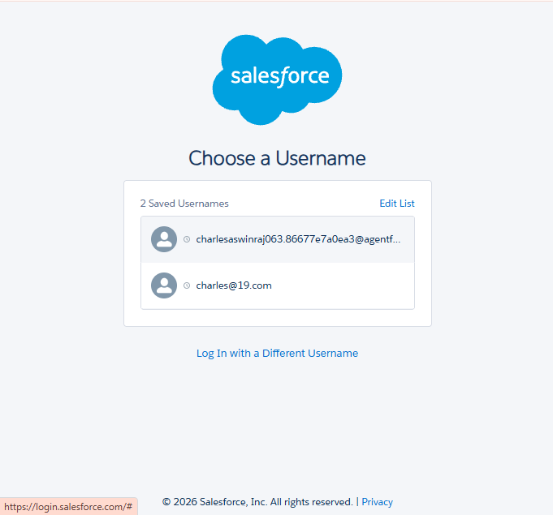

## Completion checks

Update these checkboxes only after performing each check:

- [ ] The intended project environment and its type have been confirmed.
- [x] The project owner has confirmed successful Salesforce sign-in.
- [ ] Setup, Object Manager, and App Manager are accessible.
- [ ] Genuine screenshot evidence has been added.
- [ ] Any additional instructions in the course's Salesforce Account activity have been completed.

## Expected result

The project owner can access the Salesforce practice environment and the setup areas required for the next project milestones. The actual completion status should be recorded after the checks above and the course-specific requirements are satisfied.

